Equilateral Triangle
# Source: AI Source: Provided by: [Data Path: Persons Table -> ID Column: 1, Name_En Column: Motasem Essam] -> From: [ChatGPT] on [7/25/2026]
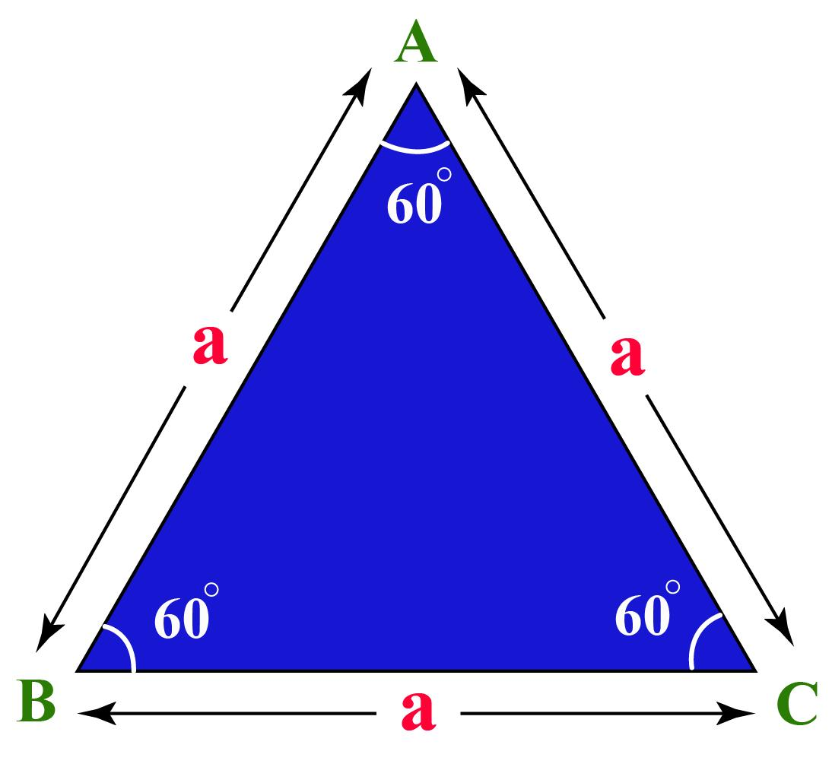
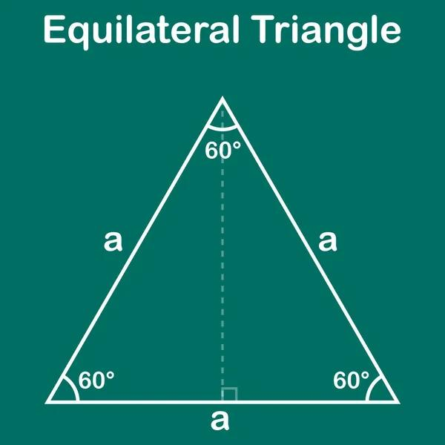
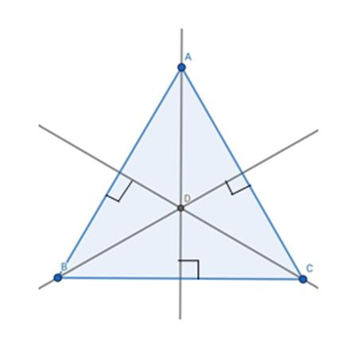
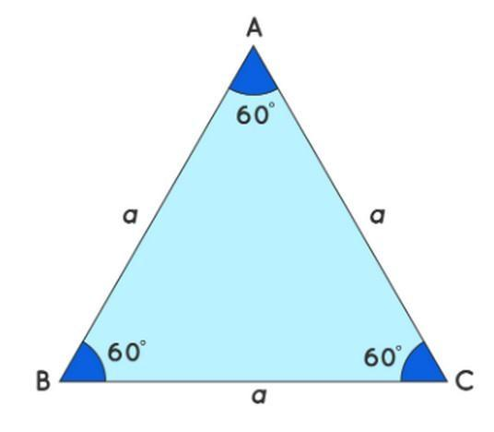
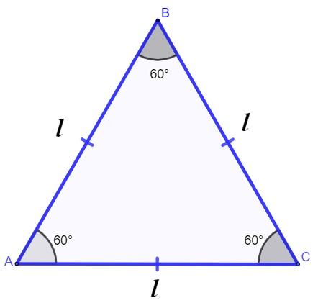

Definition
# Source: AI Source: Provided by: [Data Path: Persons Table -> ID Column: 1, Name_En Column: Motasem Essam] -> From: [ChatGPT] on [7/25/2026]
An equilateral triangle is a triangle in which all three sides have equal lengths.
For triangle $ABC$:
$$\boxed{AB=BC=CA}$$
An equilateral triangle also has three equal interior angles. Since the angles of a triangle sum to ${180}^{∘}$:
$$\boxed{∠A=∠B=∠C={60}^{∘}}$$
Thus, an equilateral triangle is both:
- Equilateral — all sides are equal.
- Equiangular — all angles are equal.
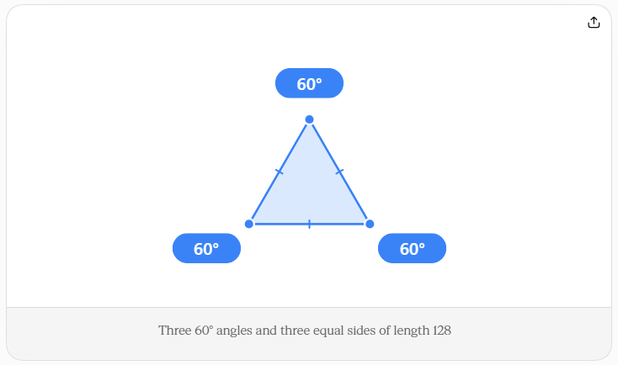

Classification
# Source: AI Source: Provided by: [Data Path: Persons Table -> ID Column: 1, Name_En Column: Motasem Essam] -> From: [ChatGPT] on [7/25/2026]
Triangles can be classified by their side lengths into three main types:
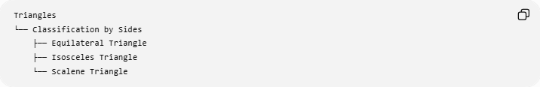
Triangles
└── Classification by Sides
├── Equilateral Triangle
├── Isosceles Triangle
└── Scalene Triangle
An equilateral triangle is the type in which:
$$\boxed{a=b=c}$$

Fundamental Elements
# Source: AI Source: Provided by: [Data Path: Persons Table -> ID Column: 1, Name_En Column: Motasem Essam] -> From: [ChatGPT] on [7/25/2026]
For an equilateral triangle with side length $a$:
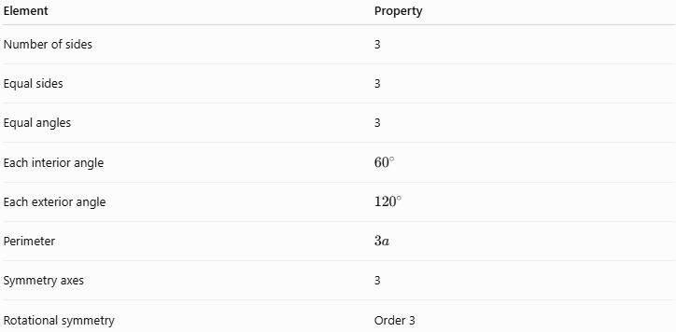
Element | Property
Number of sides | 3
Equal sides | 3
Equal angles | 3
Each interior angle | $${60}^{∘}$$
Each exterior angle | $${120}^{∘}$$
Perimeter | $$3a$$
Symmetry axes | 3
Rotational symmetry | Order 3

Main Properties

1. Three Equal Sides
# Source: AI Source: Provided by: [Data Path: Persons Table -> ID Column: 1, Name_En Column: Motasem Essam] -> From: [ChatGPT] on [7/25/2026]
The defining property is:
$$\boxed{AB=BC=CA}$$

2. Three Equal Angles
# Source: AI Source: Provided by: [Data Path: Persons Table -> ID Column: 1, Name_En Column: Motasem Essam] -> From: [ChatGPT] on [7/25/2026]
All three interior angles measure:
$$\boxed{{60}^{∘}}$$
Therefore:
$$\boxed{∠A=∠B=∠C={60}^{∘}}$$

3. Equiangular
# Source: AI Source: Provided by: [Data Path: Persons Table -> ID Column: 1, Name_En Column: Motasem Essam] -> From: [ChatGPT] on [7/25/2026]
Because all three angles are equal, every equilateral triangle is also equiangular.
In Euclidean geometry:
$$\boxed{\text{Equilateral}⇒\text{Equiangular}}$$

4. Every Median Is Also an Altitude
# Source: AI Source: Provided by: [Data Path: Persons Table -> ID Column: 1, Name_En Column: Motasem Essam] -> From: [ChatGPT] on [7/25/2026]
If $D$is the midpoint of $BC$, then $AD$is simultaneously:
- a median,
- an altitude,
- an angle bisector,
- a perpendicular bisector of $BC$.
Therefore:
$$\boxed{AD⊥BC}$$
and:
$$\boxed{BD=DC}$$
and:
$$\boxed{∠BAD=∠DAC={30}^{∘}}$$

Centers of an Equilateral Triangle
# Source: AI Source: Provided by: [Data Path: Persons Table -> ID Column: 1, Name_En Column: Motasem Essam] -> From: [ChatGPT] on [7/25/2026]
One of the most important properties of an equilateral triangle is that its major triangle centers all coincide.
The following points are the same point:
$$\boxed{G=I=O=H}$$
where:
- $G$= centroid
- $I$= incenter
- $O$= circumcenter
- $H$= orthocenter
The common point is therefore simultaneously:
- the centroid,
- the incenter,
- the circumcenter,
- the orthocenter.
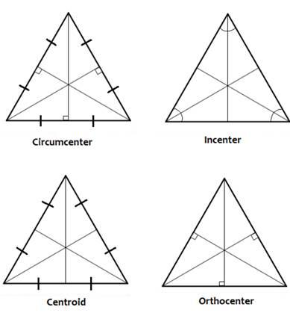
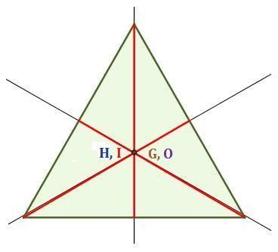
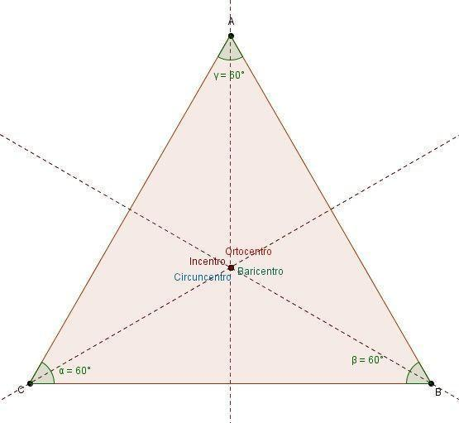

Altitude
# Source: AI Source: Provided by: [Data Path: Persons Table -> ID Column: 1, Name_En Column: Motasem Essam] -> From: [ChatGPT] on [7/25/2026]
For an equilateral triangle with side length $a$, the altitude is:
$$\boxed{h=\frac{\sqrt{3}}{2}a}$$
The altitude divides the triangle into two congruent ${30}^{∘}-{60}^{∘}-{90}^{∘}$right triangles.

Area
# Source: AI Source: Provided by: [Data Path: Persons Table -> ID Column: 1, Name_En Column: Motasem Essam] -> From: [ChatGPT] on [7/25/2026]
Using the ordinary triangle area formula:
$$A=\frac{1}{2}bh$$
with:
$$b=a$$
and:
$$h=\frac{\sqrt{3}}{2}a$$
we obtain:
$$A=\frac{1}{2}\left(a\right)\left(\frac{\sqrt{3}}{2}a\right)$$
Therefore:
$$\boxed{A=\frac{\sqrt{3}}{4}a^{2}}$$

Perimeter
# Source: AI Source: Provided by: [Data Path: Persons Table -> ID Column: 1, Name_En Column: Motasem Essam] -> From: [ChatGPT] on [7/25/2026]
Since all three sides have length $a$:
$$P=a+a+a$$
Therefore:
$$\boxed{P=3a}$$

Inradius
# Source: AI Source: Provided by: [Data Path: Persons Table -> ID Column: 1, Name_En Column: Motasem Essam] -> From: [ChatGPT] on [7/25/2026]
The inradius $r$of an equilateral triangle is:
$$\boxed{r=\frac{\sqrt{3}}{6}a}$$
It can also be expressed in terms of the altitude:
$$\boxed{r=\frac{h}{3}}$$

Circumradius
# Source: AI Source: Provided by: [Data Path: Persons Table -> ID Column: 1, Name_En Column: Motasem Essam] -> From: [ChatGPT] on [7/25/2026]
The circumradius $R$is:
$$\boxed{R=\frac{\sqrt{3}}{3}a}$$
or:
$$\boxed{R=\frac{2h}{3}}$$
The relationship between circumradius and inradius is:
$$\boxed{R=2r}$$

Relationship Between the Centers
# Source: AI Source: Provided by: [Data Path: Persons Table -> ID Column: 1, Name_En Column: Motasem Essam] -> From: [ChatGPT] on [7/25/2026]
For an equilateral triangle:
$$\boxed{G=I=O=H}$$
Therefore, the usual distances between these centers are zero:
$$OG=GI=IO=OH=GH=0$$
because they represent the same point.
This is also why the Euler line is not uniquely determined in an equilateral triangle: there is only one common center point rather than three distinct centers determining a unique line.

Symmetry
# Source: AI Source: Provided by: [Data Path: Persons Table -> ID Column: 1, Name_En Column: Motasem Essam] -> From: [ChatGPT] on [7/25/2026]
An equilateral triangle has three lines of symmetry.
Each symmetry axis:
- passes through one vertex,
- passes through the midpoint of the opposite side,
- is simultaneously a median,
- is simultaneously an altitude,
- is simultaneously an angle bisector,
- is simultaneously a perpendicular bisector.
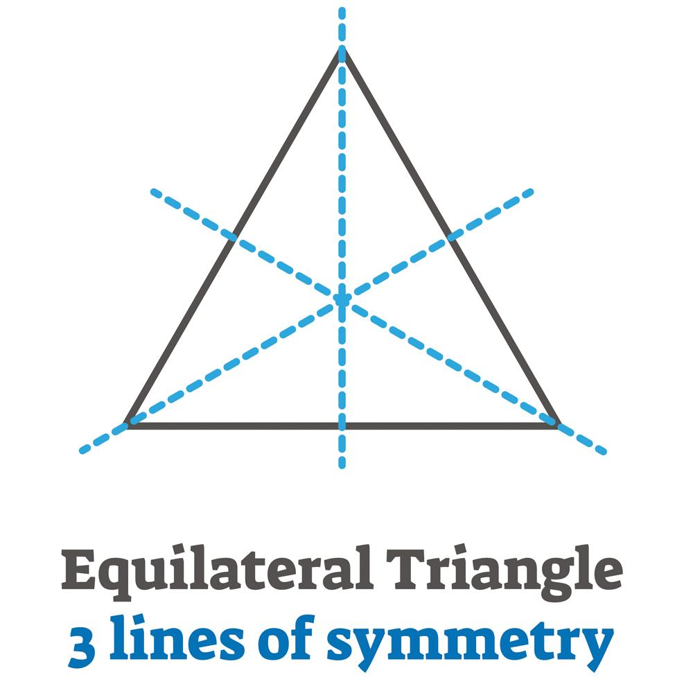
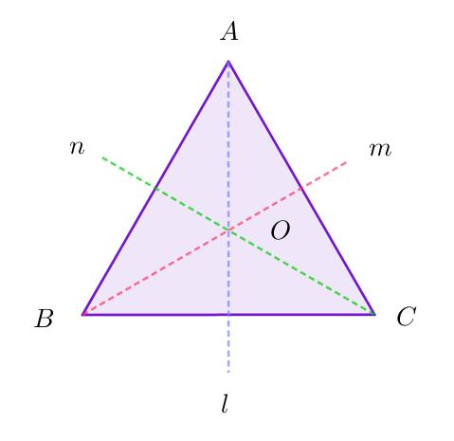
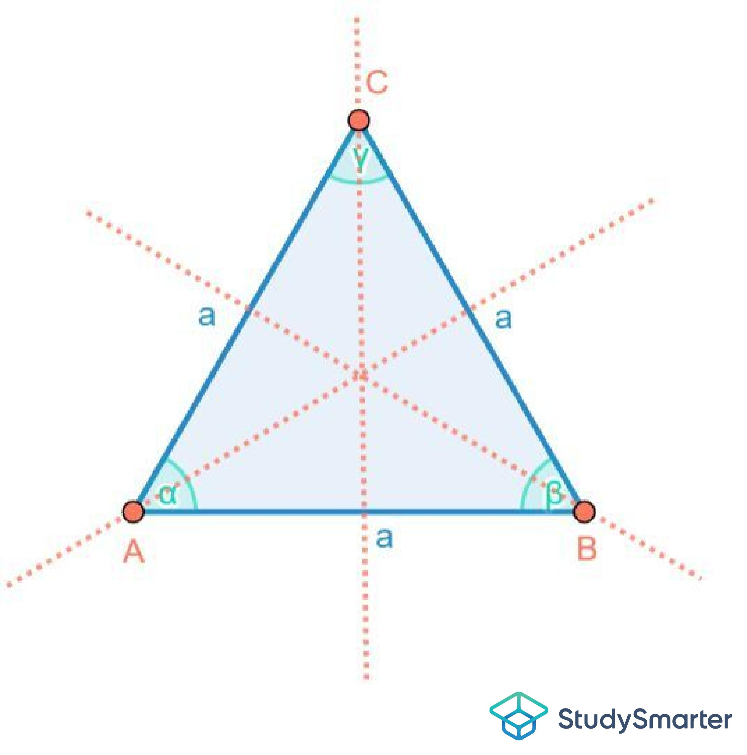
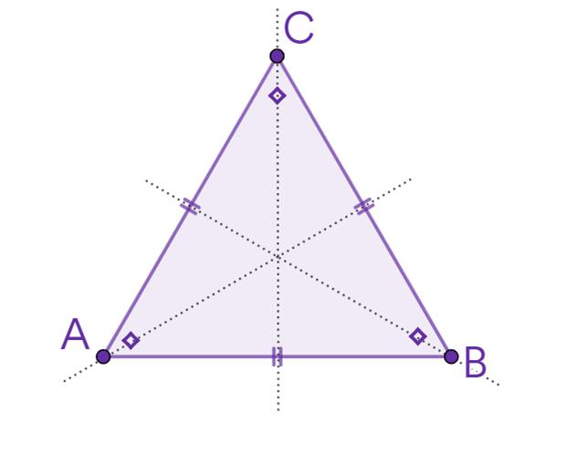

Rotational Symmetry
# Source: AI Source: Provided by: [Data Path: Persons Table -> ID Column: 1, Name_En Column: Motasem Essam] -> From: [ChatGPT] on [7/25/2026]
An equilateral triangle has rotational symmetry of order 3.
It maps onto itself after rotations of:
$$\boxed{{120}^{∘}} \\ \boxed{{240}^{∘}}$$
and:
$$\boxed{{360}^{∘}}$$
The smallest non-zero rotational angle is:
$$\boxed{{120}^{∘}}$$

Exterior Angles
# Source: AI Source: Provided by: [Data Path: Persons Table -> ID Column: 1, Name_En Column: Motasem Essam] -> From: [ChatGPT] on [7/25/2026]
Each exterior angle of an equilateral triangle is:
$${180}^{∘}-{60}^{∘}$$
so:
$$\boxed{{120}^{∘}}$$
The three exterior angles therefore satisfy:
$${120}^{∘}+{120}^{∘}+{120}^{∘}={360}^{∘}$$

Example
# Source: AI Source: Provided by: [Data Path: Persons Table -> ID Column: 1, Name_En Column: Motasem Essam] -> From: [ChatGPT] on [7/25/2026]
Suppose an equilateral triangle has:
$$a=10\text{ cm}$$
Perimeter
$$P=3\left(10\right) \\ \boxed{P=30\text{ cm}}$$
Height
$$h=\frac{\sqrt{3}}{2}\left(10\right) \\ \boxed{h=5\sqrt{3}\text{ cm}}$$
Area
$$A=\frac{\sqrt{3}}{4}{\left(10\right)}^{2} \\ \boxed{A=25\sqrt{3}{\text{ cm}}^{2}}$$
approximately:
$$\boxed{A≈43.30{\text{ cm}}^{2}}$$
Inradius
$$r=\frac{\sqrt{3}}{6}\left(10\right) \\ \boxed{r=\frac{5\sqrt{3}}{3}\text{ cm}}$$
Circumradius
$$R=\frac{\sqrt{3}}{3}\left(10\right) \\ \boxed{R=\frac{10\sqrt{3}}{3}\text{ cm}}$$

Equilateral Triangle and Heron's Formula
# Source: AI Source: Provided by: [Data Path: Persons Table -> ID Column: 1, Name_En Column: Motasem Essam] -> From: [ChatGPT] on [7/25/2026]
Heron's Formula can also calculate the area.
For:
$$a=b=c$$
the semiperimeter is:
$$s=\frac{3a}{2}$$
Heron's Formula gives:
$$A=\sqrt{s\left(s-a\right)\left(s-b\right)\left(s-c\right)}$$
which simplifies to:
$$\boxed{A=\frac{\sqrt{3}}{4}a^{2}}$$
Thus, the equilateral-triangle area formula is a special case of Heron's Formula.

Equilateral Triangle and the ${30}^{∘}-{60}^{∘}-{90}^{∘}$Triangle
# Source: AI Source: Provided by: [Data Path: Persons Table -> ID Column: 1, Name_En Column: Motasem Essam] -> From: [ChatGPT] on [7/25/2026]
Drawing an altitude divides an equilateral triangle into two congruent right triangles.
Each right triangle has angles:
$$\boxed{{30}^{∘}, {60}^{∘}, {90}^{∘}}$$
and side ratio:
$$\boxed{1:\sqrt{3}:2}$$
This makes equilateral triangles an important source of ${30}^{∘}-{60}^{∘}-{90}^{∘}$triangle relationships.

Comparison with Other Triangle Types by Sides
# Source: AI Source: Provided by: [Data Path: Persons Table -> ID Column: 1, Name_En Column: Motasem Essam] -> From: [ChatGPT] on [7/25/2026]
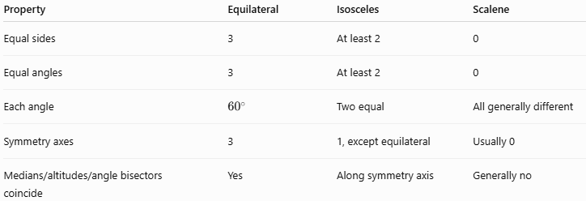
Property | Equilateral | Isosceles | Scalene
Equal sides | 3 | At least 2 | 0
Equal angles | 3 | At least 2 | 0
Each angle | $${60}^{∘}$$ | Two equal | All generally different
Symmetry axes | 3 | 1, except equilateral | Usually 0
Medians/altitudes/angle bisectors coincide | Yes | Along symmetry axis | Generally no
Note: An equilateral triangle is also a special case of an isosceles triangle under the broad definition of isosceles as having at least two equal sides. In a classification system that uses "exactly two equal sides," however, equilateral triangles are treated separately.

Equiangular Triangle
# Source: AI Source: Provided by: [Data Path: Persons Table -> ID Column: 1, Name_En Column: Motasem Essam] -> From: [ChatGPT] on [7/25/2026]
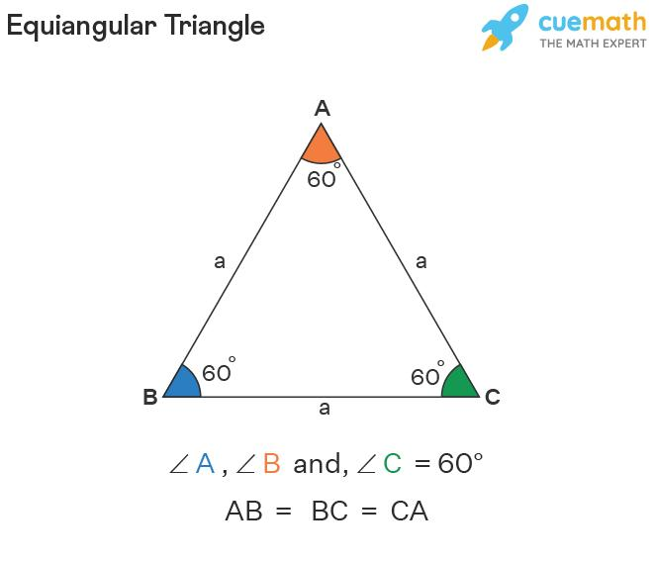
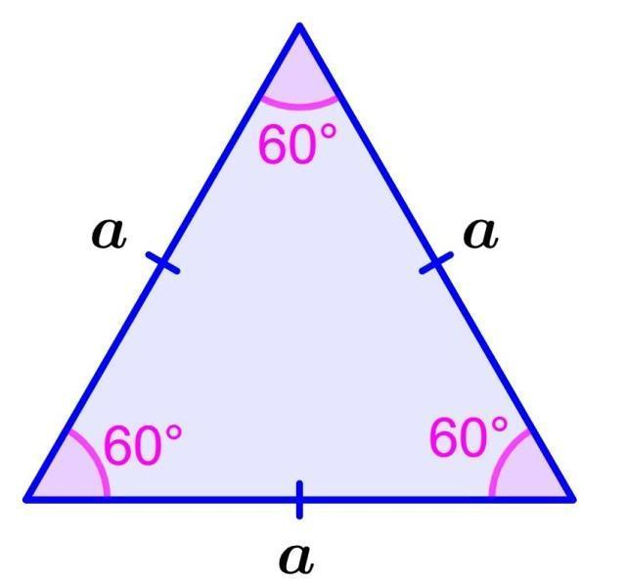
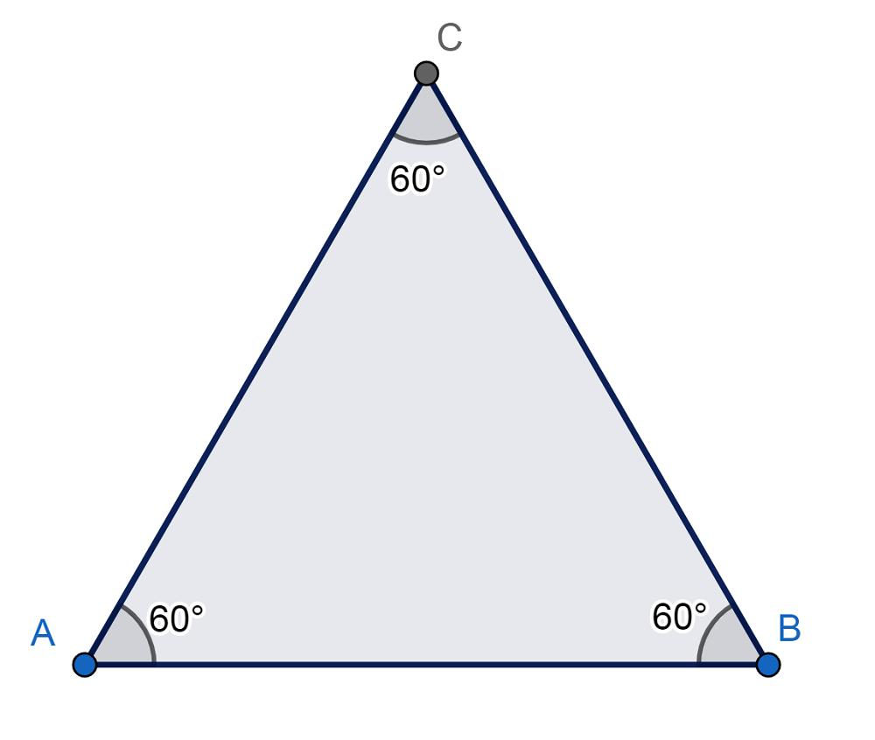
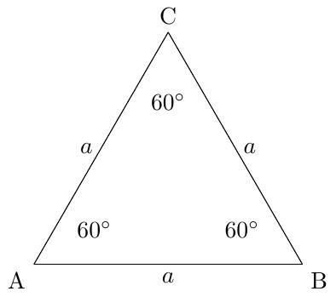

Definition
# Source: AI Source: Provided by: [Data Path: Persons Table -> ID Column: 1, Name_En Column: Motasem Essam] -> From: [ChatGPT] on [7/25/2026]
An Equiangular Triangle is a triangle in which all three interior angles are equal in measure.
Since the sum of the interior angles of every triangle is ${180}^{∘}$:
$$\boxed{∠A=∠B=∠C={60}^{∘}}$$
Therefore, every equiangular triangle is also an acute triangle.

Fundamental Concept
# Source: AI Source: Provided by: [Data Path: Persons Table -> ID Column: 1, Name_En Column: Motasem Essam] -> From: [ChatGPT] on [7/25/2026]
For any triangle:
$$∠A+∠B+∠C={180}^{∘}$$
If all three angles are equal:
$$∠A=∠B=∠C$$
then:
$$3∠A={180}^{∘}$$
so:
$$\boxed{∠A=∠B=∠C={60}^{∘}}$$
Thus, there is only one possible angle measure for an equiangular triangle: ${60}^{∘}$.

Relationship to Equilateral Triangle
# Source: AI Source: Provided by: [Data Path: Persons Table -> ID Column: 1, Name_En Column: Motasem Essam] -> From: [ChatGPT] on [7/25/2026]
An important theorem states:
$$\boxed{\text{Equiangular Triangle }⟺\text{ Equilateral Triangle}}$$
For triangles, having three equal angles is equivalent to having three equal sides.
Therefore:
$$\boxed{∠A=∠B=∠C}$$
implies:
$$\boxed{AB=BC=CA}$$
And:
$$\boxed{AB=BC=CA}$$
implies:
$$\boxed{∠A=∠B=∠C={60}^{∘}}$$
So an equiangular triangle is always an equilateral triangle, and an equilateral triangle is always equiangular.

Classification
# Source: AI Source: Provided by: [Data Path: Persons Table -> ID Column: 1, Name_En Column: Motasem Essam] -> From: [ChatGPT] on [7/25/2026]
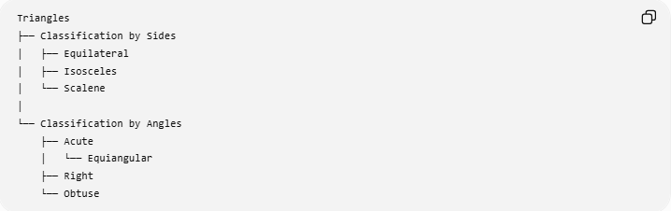
Triangles
├── Classification by Sides
│ ├── Equilateral
│ ├── Isosceles
│ └── Scalene
│
└── Classification by Angles
├── Acute
│ └── Equiangular
├── Right
└── Obtuse
However, for a precise taxonomy, Equiangular is better treated as an angle-based property/classification, while Equilateral is the corresponding side-based classification.
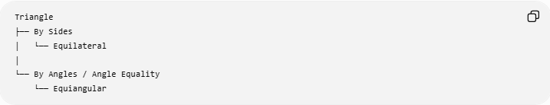
Triangle
├── By Sides
│ └── Equilateral
│
└── By Angles / Angle Equality
└── Equiangular
Because every equiangular triangle is equilateral:
$$\boxed{\text{Equiangular}=\text{Equilateral for triangles}}$$

Main Properties
# Source: AI Source: Provided by: [Data Path: Persons Table -> ID Column: 1, Name_En Column: Motasem Essam] -> From: [ChatGPT] on [7/25/2026]
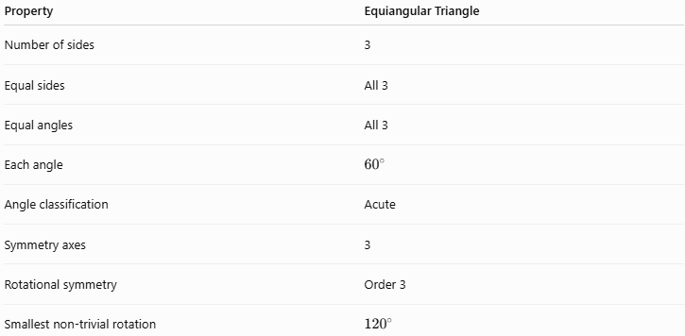
Property | Equiangular Triangle
Number of sides | 3
Equal sides | All 3
Equal angles | All 3
Each angle | $${60}^{∘}$$
Angle classification | Acute
Symmetry axes | 3
Rotational symmetry | Order 3
Smallest non-trivial rotation | $${120}^{∘}$$

Side Lengths
# Source: AI Source: Provided by: [Data Path: Persons Table -> ID Column: 1, Name_En Column: Motasem Essam] -> From: [ChatGPT] on [7/25/2026]
If each side has length $a$:
$$\boxed{AB=BC=CA=a}$$
The perimeter is:
$$\boxed{P=3a}$$

Area
# Source: AI Source: Provided by: [Data Path: Persons Table -> ID Column: 1, Name_En Column: Motasem Essam] -> From: [ChatGPT] on [7/25/2026]
The area of an equiangular triangle is:
$$\boxed{A=\frac{\sqrt{3}}{4}a^{2}}$$
The altitude is:
$$\boxed{h=\frac{\sqrt{3}}{2}a}$$
Since:
$$A=\frac{1}{2}ah$$
substitution gives:
$$A=\frac{1}{2}a\left(\frac{\sqrt{3}}{2}a\right) \\ \boxed{A=\frac{\sqrt{3}}{4}a^{2}}$$

Triangle Centers
# Source: AI Source: Provided by: [Data Path: Persons Table -> ID Column: 1, Name_En Column: Motasem Essam] -> From: [ChatGPT] on [7/25/2026]
The equiangular triangle has a special relationship among its centers.
The following points are all the same point:
$$\boxed{G=I=O=H}$$
where:
- $G$= centroid
- $I$= incenter
- $O$= circumcenter
- $H$= orthocenter
This common point is the center of the triangle's symmetry.

Median, Altitude, and Angle Bisector
# Source: AI Source: Provided by: [Data Path: Persons Table -> ID Column: 1, Name_En Column: Motasem Essam] -> From: [ChatGPT] on [7/25/2026]
Every median is simultaneously:
- an altitude,
- an angle bisector,
- a perpendicular bisector.
Therefore:
$$\boxed{\text{Median}=\text{Altitude}=\text{Angle Bisector}=\text{Perpendicular Bisector}}$$
There are three such lines, corresponding to the three vertices.

Inradius and Circumradius
# Source: AI Source: Provided by: [Data Path: Persons Table -> ID Column: 1, Name_En Column: Motasem Essam] -> From: [ChatGPT] on [7/25/2026]
For side length $a$, the inradius is:
$$\boxed{r=\frac{\sqrt{3}}{6}a}$$
The circumradius is:
$$\boxed{R=\frac{\sqrt{3}}{3}a}$$
Therefore:
$$\boxed{R=2r}$$

Example
# Source: AI Source: Provided by: [Data Path: Persons Table -> ID Column: 1, Name_En Column: Motasem Essam] -> From: [ChatGPT] on [7/25/2026]
Suppose:
$$AB=BC=CA=6$$
Then the triangle is equilateral and therefore equiangular.
Each angle is:
$$\boxed{{60}^{∘}}$$
Its perimeter is:
$$P=3\left(6\right)=\boxed{18}$$
Its altitude is:
$$h=\frac{\sqrt{3}}{2}\left(6\right)=\boxed{3\sqrt{3}}$$
Its area is:
$$A=\frac{\sqrt{3}}{4}\left(6^{2}\right) \\ \boxed{A=9\sqrt{3}}$$

Comparison with Other Angle Classifications
# Source: AI Source: Provided by: [Data Path: Persons Table -> ID Column: 1, Name_En Column: Motasem Essam] -> From: [ChatGPT] on [7/25/2026]
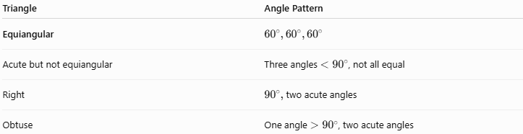
Triangle | Angle Pattern
Equiangular | $${60}^{∘},{60}^{∘},{60}^{∘}$$
Acute but not equiangular | Three angles $<{90}^{∘}$, not all equal
Right | ${90}^{∘},$two acute angles
Obtuse | One angle $>{90}^{∘}$, two acute angles
An equiangular triangle is therefore a special case of an acute triangle:
$$\boxed{\text{Equiangular}⊂\text{Acute}}$$

Key Points
# Source: AI Source: Provided by: [Data Path: Persons Table -> ID Column: 1, Name_En Column: Motasem Essam] -> From: [ChatGPT] on [7/25/2026]
- All three angles are equal.
- Every angle is exactly:
$$\boxed{{60}^{∘}}$$
- All three sides are equal.
- Therefore, every equiangular triangle is equilateral.
- Every equilateral triangle is equiangular.
- It is always acute.
- It has three lines of symmetry.
- It has rotational symmetry of order $3$.
- Its centroid, incenter, circumcenter, and orthocenter coincide:
$$\boxed{G=I=O=H}$$
- Its median, altitude, angle bisector, and perpendicular bisector coincide for each vertex.

Conclusion
# Source: AI Source: Provided by: [Data Path: Persons Table -> ID Column: 1, Name_En Column: Motasem Essam] -> From: [ChatGPT] on [7/25/2026]
An Equiangular Triangle is a triangle whose three interior angles are equal. Because the angles of a triangle sum to ${180}^{∘}$, each angle must be ${60}^{∘}$. This makes every equiangular triangle equilateral, giving it maximum symmetry among triangles.
$$\boxed{\text{Equiangular }⟺\text{ Equilateral }⟺ {60}^{∘},{60}^{∘},{60}^{∘}}$$

Real-World Applications
# Source: AI Source: Provided by: [Data Path: Persons Table -> ID Column: 1, Name_En Column: Motasem Essam] -> From: [ChatGPT] on [7/25/2026]
Equilateral triangles appear in:
- Structural engineering.
- Truss structures.
- Architectural designs.
- Tiling and tessellations.
- Triangular patterns.
- Mechanical components.
- Engineering drawings.
- Geometric modeling.
- Computer graphics.
Their equal sides and equal angles make them especially useful when uniformity and symmetry are important.

Key Formulas
# Source: AI Source: Provided by: [Data Path: Persons Table -> ID Column: 1, Name_En Column: Motasem Essam] -> From: [ChatGPT] on [7/25/2026]
For an equilateral triangle with side length $a$:
Perimeter
$$\boxed{P=3a}$$
Height
$$\boxed{h=\frac{\sqrt{3}}{2}a}$$
Area
$$\boxed{A=\frac{\sqrt{3}}{4}a^{2}}$$
Inradius
$$\boxed{r=\frac{\sqrt{3}}{6}a}$$
Circumradius
$$\boxed{R=\frac{\sqrt{3}}{3}a}$$
Circumradius–Inradius Relationship
$$\boxed{R=2r}$$

Taxonomy
# Source: AI Source: Provided by: [Data Path: Persons Table -> ID Column: 1, Name_En Column: Motasem Essam] -> From: [ChatGPT] on [7/25/2026]
For your triangle classification structure:
Plane Geometry
└── Triangles
└── Triangle Classification
└── Classification by Sides
├── Equilateral Triangle
├── Isosceles Triangle
└── Scalene Triangle
The topic should therefore be classified as:
$$\boxed{\text{Triangles }\text{→} \text{Classification} \text{by} \text{Sides} \text{→} \text{Equilateral} \text{Triangle}}$$

Key Points
# Source: AI Source: Provided by: [Data Path: Persons Table -> ID Column: 1, Name_En Column: Motasem Essam] -> From: [ChatGPT] on [7/25/2026]
- An equilateral triangle has three equal sides:
$$\boxed{a=b=c}$$
- It has three equal angles:
$$\boxed{{60}^{∘},{60}^{∘},{60}^{∘}}$$
- Every median is also an altitude, angle bisector, and perpendicular bisector.
- The centroid, incenter, circumcenter, and orthocenter coincide:
$$\boxed{G=I=O=H}$$
- Its height is:
$$\boxed{h=\frac{\sqrt{3}}{2}a}$$
- Its area is:
$$\boxed{A=\frac{\sqrt{3}}{4}a^{2}}$$
- It has 3 lines of symmetry and rotational symmetry of order 3.
- It is a special case of both an isosceles and an acute triangle.

Conclusion
# Source: AI Source: Provided by: [Data Path: Persons Table -> ID Column: 1, Name_En Column: Motasem Essam] -> From: [ChatGPT] on [7/25/2026]
An equilateral triangle is the most symmetric triangle classified by side lengths. Its three sides and three angles are equal, and its medians, altitudes, angle bisectors, and perpendicular bisectors coincide. Consequently, its four principal triangle centers—centroid, incenter, circumcenter, and orthocenter—are all the same point.

